**Daily Assessment**

**Muhammad Ammar Chaudhry**

**SU92-BSCSM-F23-269**

**BSCS-1G**

**----------------------------------------------------------------------------------------------------**

Q#31:

#include <iostream>

using namespace std;

void addFractions(int a, int b, int c, int d, int& numerator, int& denominator)

{

numerator = (a * d) + (b * c);

denominator = b * d;

}

int main()

{

int numerator1, denominator1, numerator2, denominator2;

cout << "Enter the first fraction in the form a/b: ";

char slash;

cin >> numerator1 >> slash >> denominator1;

cout << "Enter the second fraction in the form c/d: ";

cin >> numerator2 >> slash >> denominator2;

if (denominator1 != 0 && denominator2 != 0)

{

int resultNumerator, resultDenominator;

addFractions(numerator1, denominator1, numerator2, denominator2, resultNumerator, resultDenominator);

cout << "The sum of the fractions is: " << resultNumerator << "/" << resultDenominator << endl;

} else {

cout << "Denominator cannot be zero. Please enter valid fractions." << endl;

}

return 0;

}

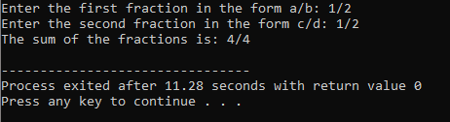

Q#32:

#include <iostream>

using namespace std;

int main() {

int int1, int2;

double dec1, dec2;

// Input data: 56.50 67 48 62.72

cout << "Enter values for dec1, int1, int2, and dec2: ";

// Scenario a

cin >> dec1 >> int1 >> int2 >> dec2;

cout << "Scenario a: dec1=" << dec1 << ", int1=" << int1 << ", int2=" << int2 << ", dec2=" << dec2 << endl;

// Scenario b

cin >> int1 >> dec1 >> dec2 >> int1;

cout << "Scenario b: int1=" << int1 << ", dec1=" << dec1 << ", dec2=" << dec2 << ", int1=" << int1 << endl;

// Scenario c

cin >> dec1 >> dec2 >> int1 >> int2;

cout << "Scenario c: dec1=" << dec1 << ", dec2=" << dec2 << ", int1=" << int1 << ", int2=" << int2 << endl;

// Scenario d

cin >> int1 >> dec1 >> int2 >> dec2;

cout << "Scenario d: int1=" << int1 << ", dec1=" << dec1 << ", int2=" << int2 << ", dec2=" << dec2 << endl;

// Scenario e

cin >> int1 >> int2 >> dec1 >> dec2;

cout << "Scenario e: int1=" << int1 << ", int2=" << int2 << ", dec1=" << dec1 << ", dec2=" << dec2 << endl;

return 0;

}

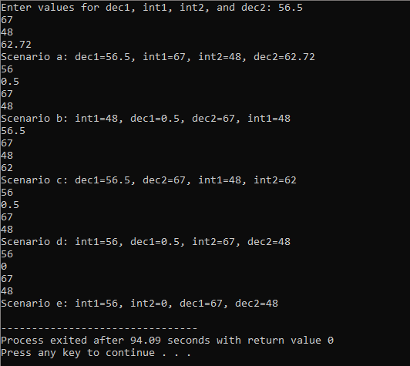

Q#33:

#include <iostream>

using namespace std;

int main() {

int x, y, z;

char ch;

// Input: 78 86 18 #42 &

cout << "Enter values for x, y, z, and ch: ";

// Scenario a

cin >> x >> y >> z >> ch;

cout << "Scenario a: x=" << x << ", y=" << y << ", z=" << z << ", ch=" << ch << endl;

// Scenario b

cin >> ch >> x >> y >> z;

cout << "Scenario b: x=" << x << ", y=" << y << ", z=" << z << ", ch=" << ch << endl;

// Scenario c

cin >> x;

cin.get(ch);

cin >> y >> z;

cout << "Scenario c: x=" << x << ", y=" << y << ", z=" << z << ", ch=" << ch << endl;

// Scenario d

cin >> x >> ch >> y >> z;

cout << "Scenario d: x=" << x << ", y=" << y << ", z=" << z << ", ch=" << ch << endl;

// Scenario e

cin.get(ch);

cin >> x >> y >> z;

cout << "Scenario e: x=" << x << ", y=" << y << ", z=" << z << ", ch=" << ch << endl;

return 0;

}

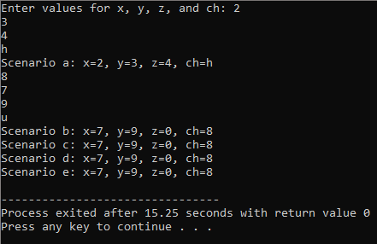

Q#34:

#include <iostream>

using namespace std;

int main() {

int int1, int2;

double dec;

char ch;

// Scenario a

cout << "Enter values for int1, ch, int2, and dec (a): ";

cin >> int1 >> ch >> int2 >> dec;

cout << "Scenario a: int1=" << int1 << ", ch=" << ch << ", int2=" << int2 << ", dec=" << dec << endl;

// Scenario b

cout << "Enter values for int1, ch, int2, and dec (b): ";

cin >> int1 >> ch >> int2 >> dec;

cout << "Scenario b: int1=" << int1 << ", ch=" << ch << ", int2=" << int2 << ", dec=" << dec << endl;

// Scenario c

cout << "Enter values for int1, ch, int2, and dec (c): ";

cin >> int1 >> ch >> dec >> int2;

cout << "Scenario c: int1=" << int1 << ", ch=" << ch << ", dec=" << dec << ", int2=" << int2 << endl;

return 0;

}

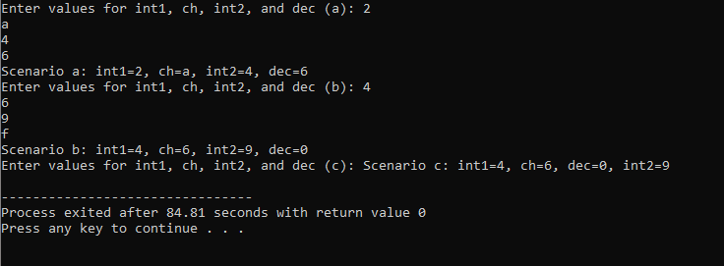

Q#35:

#include <iostream>

#include <string>

using namespace std;

int main() {

double height;

char ch;

string name;

cout << "Enter height and name (scenario a): ";

cin >> height;

cin.get(ch);

getline(cin, name);

cout << "Scenario a:\n";

cout << "Height: " << height << "\n";

cout << "Char: " << ch << "\n";

cout << "Name: " << name << "\n\n";

height = 0.0;

ch = '\0';

name = "";

cout << "Enter height and name (scenario b): ";

cin >> height;

cin.get(ch);

getline(cin, name);

cout << "Scenario b:\n";

cout << "Height: " << height << "\n";

cout << "Char: " << ch << "\n";

cout << "Name: " << name << "\n";

return 0;

}

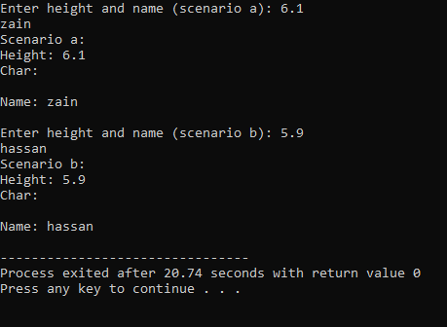

Q#36:

#include <iostream>

using namespace std;

int main() {

int num;

char discard;

// Scenario a

cout << "Scenario a: ";

cin.get(discard);

cin >> num;

cout << "num = " << num << ", discard = " << discard << endl;

// Scenario b

cout << "Scenario b: ";

discard = cin.peek();

cin >> num;

cout << "num = " << num << ", discard = " << discard << endl;

// Scenario c

cout << "Scenario c: ";

cin.get(discard);

cin.putback(discard);

cin >> discard;

cin >> num;

cout << "num = " << num << ", discard = " << discard << endl;

return 0;

}

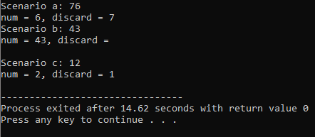

Q#37:

#include <iostream>

using namespace std;

int main() {

int num1, num2, newNum;

double x, y;

num1 = 35;

num1 = 5;

num2 = 2 + num1;

num1 = num2 / 3;

x = 12 * num1 - 15.3;

newNum = static_cast<int>(x) % 5;

x = x + y - 5;

newNum = num1 + static_cast<int>(4.6 / 2);

cout << "num1: " << num1 << endl;

cout << "num2: " << num2 << endl;

cout << "newNum: " << newNum << endl;

cout << "x: " << x << endl;

cout << "y: " << y << endl;

return 0;

}

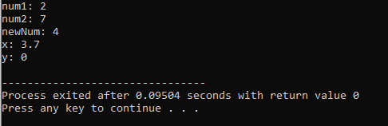

Q#38:

#include <iostream>

using namespace std;

int main() {

int a = 25, b = 20;

double c = 5.0;

// a.

cout << "a. " << a * 2 * b << endl;

// b.

cout << "b. " << a + b / 2.0 + 1.5 * c << endl;

// c.

cout << "c. " << a / static_cast<double>(b) << endl;

// d.

cout << "d. " << 62 % 28 + a / c << endl;

// e.

cout << "e. " << static_cast<int>(c) % 3 + 7 << endl;

// f.

cout << "f. " << 22.5 / 2 + 14.0 * 3.5 + 28 << endl;

// g.

cout << "g. " << 2 / (c - static_cast<int>(c + 1.2)) << endl;

return 0;

}

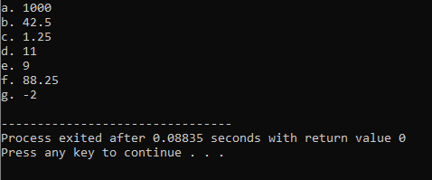

Q#39:

#include <iostream>

using namespace std;

const int NUM = 10;

const double X = 20.5;

int main()

{

int firstNum, secondNum;

double z;

char grade;

firstNum = 62;

cout << "firstNum = " << firstNum << endl;

cout << "Enter three numbers: ";

cin >> firstNum >> z >> secondNum;

cout << endl;

cout << "The numbers you entered are "<< firstNum << ", " << z << ", and "<< secondNum << endl;

z = z - X + 2 * firstNum - secondNum;

cout << "z = " << z << endl;

cout << "Enter grade: ";

cin >> grade;

cout << endl;

cout << "The letter that follows your grade is: "<< static_cast<char>(static_cast<int>(grade) + 1)<< endl;

return 0;

}

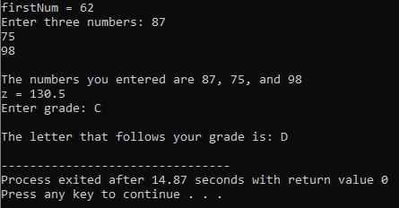

Q#40:

#include <iostream>

#include <string>

using namespace std;

const double CONVERSION = 3.5;

int main()

{

const int TEMP = 23;

string name;

int id;

int num;

double decNum;

double mysteryNum;

cout << "Enter last name: ";

cin >> name;

cout << endl;

cout << "Enter a two digit integer: ";

cin >> id;

cout << endl;

num = (id * TEMP) % (static_cast<int>(CONVERSION));

cout << "Enter a decimal number: ";

cin >> decNum;

cout << endl;

mysteryNum = decNum / CONVERSION - TEMP;

cout << "Name: " << name << endl;

cout << "Id: " << id << endl;

cout << "Mystery number: " << mysteryNum << endl;

return 0;

}

